Transport Department

Drivers Handbook

Introduction

This Handbook is a useful guide for all of us.

It sets out what we do and how we should perform our duties and what our responsibilities are.

This proceeds the previous Department Procedures and brings then all into a handy reference guide, which each of you must read and fully understand. If you do not understand any of the information contained within this guide, then please do not hesitate to contact me for clarification and guidance.

Throughout this guide, you will read about things that you already do on a daily basis, but this is just to reiterate what we do and how we should behave and how everyone is supposed to help and assist on a daily basis.

This should also show that we are a Team and therefore we are there to help and support each other on a daily basis, and that even though you are all classified as “Lone Workers”, you are infact not alone as we all support each other.

When reading through this, if there is anything that you would like to share/add, which you think would be helpful to everyone, then please let me know and I will update the guide to share these reflections.

Happy reading and remember I am there to support you as best as I can, but can only do this if you ask or request support. I’m not a mind reader!

Many thanks

Suzie

Suzie Ackerman
Transport Manager
HCRG Care Group

Conduct and Manner

All drivers must be:-

- Polite
- Courteous
- Considerate
- Helpful
- Smart in appearance
- Wearing Uniform
- ID Badge(s) on display, and shown if requested

All of our clients are issued with our Service Provision and you should also make yourself aware of what is within this document. This gives an outline of what type of service we provide to them and what is also expected of them to assist with a smooth and friendly service.

You must always be polite and friendly towards everyone you meet as part of your daily schedules of work. This is to show that we are professional and respectful to all.

You must not argue with any of our clients, but remain calm in any situation.

Please remember, the bloods etc that you are collecting/delivering could be a member of your family, and how would you feel if someone refused to wait a few minutes. Our schedules are timed, but there is leeway within the times and it is not a race to get back to the RUH to unload and get home. As your core hours are either 7am to 3pm / 8am to 4pm etc. This doesn’t mean that you finish at 3pm at home!

We wait patiently at all times We don’t get mad or annoyed

Uniforms

All drivers are issued with a uniform, which should be worn at all times, so that clients are able to recognise you. Remember you are also representing HCRG Care Group and a smart appearance is essential. The uniform supplied also complies with the HCRG Care Group Uniform Policy.

If your uniform is damaged / doesn’t fit etc, then please inform the Transport Manager, who will be able to order new for you.

The Uniform which is issued is:-

- Navy Blue Trousers / Combat Trousers
- Navy Blue Polo Shirts
- Navy Blue Fleece
- Fluorescent High-Viz Vest
- Navy Blue Baseball Cap – if required
- HCRG Care Group ID Badge
- RUH ID Badge
- B&NES Council ID Badge if necessary

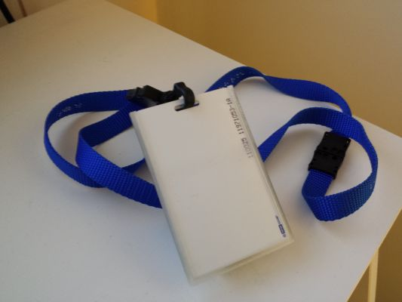
We always wear our ID Badges and are happy to show if asked | We wear our uniforms with pride | We would never come to work looking dirty and messy

Vans, Driving & Mobile Phones

Mobile Phones

All mobiles should be kept charged up at all times. Remember that it is an offence to use your phone whilst driving.

Your mobiles, also give you access to your work emails and calendar. Please note that you will need to change your password on a computer before updating on your mobile when it expires.

These are for Business Usage, and should only be used for private usage when absolutely necessary.

 | Remember the law when answering the phone |  | All our vehicles are strictly none smoking. Together with all our sites.

Vans & Vehicle Checks

You should respect and look after your works van, as if it was your own vehicle. All vehicles must:

- Be clean inside and outside
- Cab area should be tidy
- Rear of the vehicle, should be brushed/washed out on a regular basis.
- Ensure you have Gloves / Hand Gel in your vehicle
- Vehicle Information Folder
- Yellow High-Viz Vests
- Fuel Card

Vehicle Inspection sheets must be completed on a daily basis and submitted to the Transport Manager on a weekly/fortnightly basis. This should also include your fuel receipts and any notifications with regards to problems with the van that should also be reported via a telephone call to the Transport Manager.

If you have a flat tyre or a puncture, then where possible and if safe to do so, you should change this yourself. If you would like to be shown how to do this, then please ask and a member of staff who is competent in this will train you. If you are unable, then you need to contact the Breakdown Service, who will endeavour to get someone to you as a matter of urgency. Remember to inform them that you have time sensitive specimens and controlled drugs on board that are urgent for delivery.

All vans are strictly NO SMOKING. This complies with HCRG Care Group Policies and Procedures and the NHS No Smoking ban, which is place on all Healthcare premises.

Vans are issued for BUSINESS USAGE ONLY. All vans must be parked up at the end of the shift and should not be used until the next shift starts. All vans have Trackers installed in them.

The vans are not to be used for Private Usage, and no passengers should be transported in the vehicles, ie family/friends.

Please note that any mis-usage of these vehicles will lead to a verbal warning. Disregard of this warning, could result in a more formal warning and restrictions being put on the driver. The restriction would mean that you are no longer able to take the vehicle home at night, and that the van must be parked on the St Martins Hospital site and the keys are to be submitted to Switchboard, where you will need to sign them in and out every time. This may also have an impact on all employees, as it may be deemed, that everyone will have to return their vehicles back to St Martins.

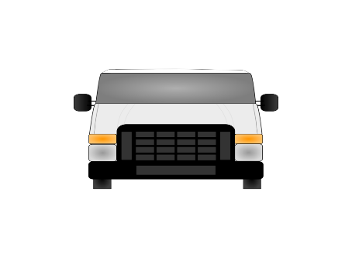
Our vans are well looked after and are kept clean and tidy | We don’t use them as our own personal vehicles

Driving Licence Checks

Each year you are also required to provide us with a Driving Licence Check Code. This is a code which is generated from the government website, and provides us with information with regards to the types of vehicles you are able to drive, any driving offences and any restrictions on your licence.

Driving Styles

As part of the yearly appraisals, there is also a check of the condition of your vehicle and your driving style. Due to this, there is a real difference between everyone and their driving styles. The key observant are:-

- Speeding (even though vans are speed limited!)
- Hard/late breaking
- Not using the correct gears for the area (ie staying in 2nd gear when could be in 4th etc)
- Forgetting that the vehicles have 5 gears and only ever using 3 of them
- Awareness of other users of the road
- Not using your indicators
- Concentration levels, easily distracted, not paying attention
- Clutch control, riding the clutch
Now we have AUTOMATIC Vans, this shouldn’t be a problem!! – Drive Safe
 | 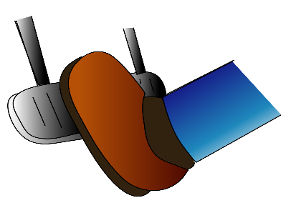 | 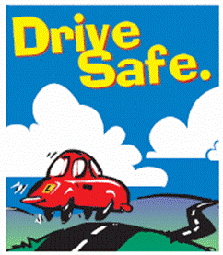
We are not racing around, just to get home early! | Breaking hard or late is dangerous, think ahead | Driving safely is the key to getting home safe and sound
Services that we Provide

We provide various services to our clients on a daily basis, which are supplied from the relevant departments within the Royal United Hospital site. Below is information on those departments and any specific information that is needed to ensure that we are compliant with the delivery / collection of them.

Each area has their own specific rules and procedures that we are required to follow.

Sterile Services

Drivers are NOT permitted to open up any of the Sterile Boxes to remove the contents, to leave just the contents at the respective location, as sometimes requested by Nursing Staff. All items must remain in the allocated box.

All dirty equipment which is collected, should only ever be taken as long as they are within the supplied boxes from Sterile.

If a client has equipment that needs to be returned, but no box, they then need to contact Sterile, to arrange for an empty box to be sent the following day. If absolutely urgent, then they must double bag the equipment and then put this into a cardboard box, which is sealed and addressed to Sterile Services, together with information on who it is from etc.

You should not handle bags of Dirty Sterile equipment, due to the high risks of cross contamination and possible harm to yourselves. This is to comply with Health & Safety and COSHH Regulations on contamination.

When collecting clean equipment, please double check that you are only taking items for your specified route. Please remember, that they don’t always get updated with the new location details when departments/services move, therefore if there is something that you are unsure of, please check with Sterile and with the Transport Manager, who can chase up the respective department.

Pathology

Specimens

When collecting specimens from the various locations that you attend on a daily basis, please ensure that you always take the blue/green transportations bags with you, and that you put the sealed specimen bags straight into the bag. You should avoid handling the specimens as much as possible.

The bags should be sealed by the clinical staff before handling over to you. This is not always possible, therefore if you are happy to seal the bags, then that is OK,

Specimens MUST NOT be carried by hand, they must be transported at all times within the blue/green pathology bags.
Don’t carry by hand, only in specific bags and containers.
You are at risk of cross contamination and infection, if not handled correctly
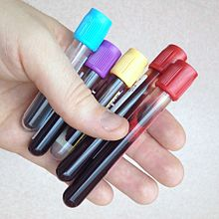

Bags must be kept upright and zipped up at all times. It is not acceptable to leave bags open in the backs of the vans or for items to be unsecure, or risk getting damaged by other items that are being carried in the vans.

All Specimen transportation bags, must be wiped out with the disinfection wipes on a weekly basis and the date recorded on your Vehicle Inspection Sheets.

When transporting 24hour Urine Samples, ensure that the lid is done up tightly on the container. If possible put this into one of the Specimen bags and seal down, then put into either the blue/green bag, remembering to stand upright, to ensure it is transported safely.

Specimens must NOT be left in:-

- Vans overnight – all bags must be emptied at Pathology at end of shift
- They are not to be dropped in the Post room, but must be taken to the Pathology Labs.
- Double check that specimens are not left in the bags, if this happens, report to Pathology asap, and to the Transport Manager.

Spillages & Spill Kits

What to do if you think that there has been a spillage, or anything has broken within the blue/green bags.
- Do not put anymore items into the bag
- Ensure it is zipped up and that it is kept upright
- Inform Pathology immediately, when get to the Specimen Reception Lab, so that they are able to deal with / contain any spillage.

If any spillage have gone into the rear of the van, then ensure that you use the Spillage Kit that you have within your vehicle. Pathology undertake all the Spillage Training, and will update/replenish any that you use. Please make the Transport Manager aware if you do not have a spill kit, or if it is out of date, so that new ones can be sourced. If you do need to use the spill kit, then you must complete an adverse event / CIRIS form to record the incident.

Pathology Stores

Pathology on a daily basis, put up supplies for deliveries to GP Surgeries, Hospital and Clinics etc. Please double check that you have the correct items for the Schedule you are working to.

If you are unsure, ie marked up as a generic name, Heart of Bath, then leave the item, and inform Pathology when able to inform them that you are unable to take, as it does not specify the actual location. If items are left on the racks for a period of time, then please inform the Transport Manager, who will then chase up Pathology to get the problem solved.

There are also trays, where Anti-D is put to go to the various Hospitals. Please ensure that you check the wipe board and the boxes and take these with you. These items cannot be left for the following day. Please also update the wipe board to show that you have taken these items.
Some Surgeries/Clinics, receive items from Pathology, which may need to be returned, ensure that any returned items are put safely outside of the storeroom, so that the Pathology Team are aware.

General

Pathology will undertake update training on a yearly basis, and will also check the vehicles to ensure that they are clean and appropriate for use. This is to comply with Pathology Audit Regulations and the transportation of Specimens. This also ensures that we comply with Health & Safety and COSHH Regulations to prevent cross contamination of items.

Pharmacy

Ensure that all Pharmacy items are secure in your vehicle at all times.

All CDs (Controlled Drugs), must be taken directly to the Ward and signed for by a member of the Nursing Staff, unless there is a different process in place for that location. Staff will be signing for a “sealed” bag, with a number on its tag. This number should be the same as the CD Book which Pharmacy give to you.

If the bag/box is not sealed, then do not take, and inform Pharmacy so that they are able to seal it.

At times Pharmacy will ask you to take certain Audit items for them, this is primarily to do with fridge items, so that they can check the temperatures to ensure that supplies are being delivered safely and in a timely manner.

Pharmacy will also ask you to undertake training, with regards to the transportation of Drugs. This is to confirm compliance with National Guidance. You will be issued with a certificate upon completion. Please give a copy to the Transport Manager, so that they are able to update your e-Learning information.

Remember that you are not to open packages from Pharmacy. You are only delivering a sealed bag.
Keep van locked at all times, especially if in bad areas

Medical Records

We are slowly taking less and less Medical Records, this is due to the various providers going over to a computerised system, whereby our records are all held within one place.

Unit this is fully completed, we will still need to move Medical Records/Notes between areas. You must ensure that any that you collect are properly packaged/sealed up and addressed correctly. If they are not, you have the right to refuse to take them, until someone packs them correctly.

This is to comply with Information Governance and Safeguarding. Any incidents, should be reported to the Transport Manager, and if possible you should take a photo of the item. This will then be put onto a CIRIS, Incident Form.

 | 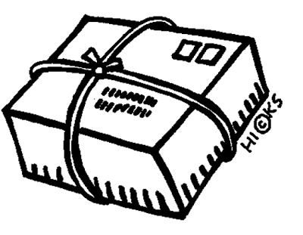
We don’t take open or non-sealed packages, especially records, if not packed or addressed correctly | A good package, is one that is addressed correctly and sealed, so no-one knows what’s inside or notes can’t escape.

MEMS (Medical Equipment)

We are asked to transport various medical equipment as part of our service. Some of these items are very expensive and fragile. Care must be taken at all times.

Items must always be boxed up and marked up for MEMS, RUH.

Items which are just lose, can be refused until they are properly packaged.

Some items are on trolleys, if it can be taken off of the trolley, then they must take it off and only give us the top part of the equipment. Some of the equipment we are no longer able to separate. Therefore, you must ensure that the top part is securely packed. If possible, the equipment should be led down on its side in the rear of the van, and nothing else should be put on top of it.

If your van is full of boxes, then you can explain due to any damage to the items, that you are unable to take that day, but will take the following day. If they insist on you still taking it, then it needs to be stressed that we will not be responsible for any additional damage done to the item.

If in doubt, then call the Transport Manager, who will assess and advise.

Internal Post Service

We provide an Internal Postal service to all of our clients. This post is sorted by the post room at the RUH on a daily basis, in readiness for us to collect each morning.

We deliver and collect thousands of items of post during the year, and 99.9% of the time, we never lose anything.

All drivers need to be aware of the post that you are delivering, and if you notice that you are collecting the same post that you delivered the previous day, then you need to let the Transport Manager know. Also, if items are going backwards and forwards, due to not being addressed correctly, then please take a photo as a CIRIS, Incident form should be completed, as part of an investigation, as to why those items are not being delivered.

Please check all post, to ensure that any Pathology Samples, ie in jiffy bags, small boxes or plastic bags are not contained within the post. Any of these should be taken directly to Pathology and not left in the post room. If there are locations which continue to do this, then there post and the specimens are to be returned to them, as there is a risk of cross-contamination, especially if a specimen breaks.

MEMS and Pathology items, should not be left/delivered to the post room. It is your responsibility to ensure that they are delivered to the correct location. The post room, are only there to sort out post.

General Information and Guidance

Changes to Schedules

It is the Surgery’s / Hospital’s / Clinic’s responsibility to inform the Transport Manager to any changes, but it is also your responsibility to inform the Transport Manager. This is due to the fact that they don’t always remember to tell everyone, but will tell their driver. These changes, could just be for a temporary period of time or on a permanent basis, ie

- Change to Surgery/Clinic Names
- Closures
- Change of Address

This information then ensures that are schedules are kept up to date and that we are still attending the correct location and not going to places that have closed.

Responsibilities

You are all responsible for the schedule of works that you undertake on a daily basis, and for any additional cover you may do as and when needed. This includes using your digression as to whether you are able to take additional items as requested. If in doubt, you must always call the Transport Manager for clarification.

At times you will be asked by GPs etc to wait for urgent specimens. The norm is to wait for approx 5 mins. If you are early to a client, compared to the time on your schedule, then you may need to wait much longer.

Do not keep chasing the staff for the sample, sometimes these are not easy to take.

If you are unable to wait any longer, then please inform the staff that you need to leave, in a friendly manner. It may be that you are able to suggest to them, that they could take to another location where you will be a bit later on and you can collect from there. It might even be that if you are having to go past the surgery again, later on, that you could possibly call back to collect. This is not to be done on a regular basis, but can be done at your digression.

Please contact the Transport Manager if you need any further advice or clarification.

Sickness

We all get sick, it’s part of the norm! Please remember to contact the Transport Manager as soon as possible if you are going to be out sick. This helps us to then sort out cover for the shift that you are out for.

Remember to keep us up to date with when you expect to return, or if you have a doctor’s appointment, the outcome, so that we can plan cover and anticipate your return.

If you are out for a long period of time, then it will be necessary to refer you to our Occupational Health Department. They will then access your fitness to return to work and offer any advice or help if necessary.

People HUB also look at patterns with regards to sickness, ie always going off sick just before leave, then claiming back. Going off after leave / Bank Holidays.

Remember to get your FLU JAB each year, either via your GP or via a session at Work. After which, please let me know so that I can update the system.

If you are sick during/before/after a booked holiday, then you will need to submit a Doctors Certificate if you are trying to claim any of your leave back. This will not automatically be given. If you do not submit a certificate, then you will not get back any leave that you may have booked during this period of time.

We also provide a Physiotherapy service to all staff, where you can self-refer to assist with any problems. We also have an EAP (Employee Assistant Programme), which is confidential and can be accessed by all staff. It may also be that we could refer you to EAP also, if we feel that this is something that would assist you. We also have a Wellbeing HUB who are able to give all sorts of advice.

Annual Leave

Not all staff get the same leave entitlement, this will be dependent on your Contract of Employment and hours of work.

Our leave year runs 1st April to 31st March.

When checking iTrent you will notice that all leave is in hours. These hours are associated to your working pattern, ie 7.5hrs per day 4 hrs per day. When booking leave this will be automatically worked out for you. Before the start of each leave period, the Transport Manager will upload all of the Bank Holiday date into iTrent. This is due to the fact that all Bank Holidays are added into your overall annual leave entitlement. Therefore as we don’t work Bank Holidays, these need to be taken off of your entitlement. The remainder is then what you are able to book as and when throughout the year. You do not lose any holidays, as it still works out exactly the same.

Leave should ideally be booked as whole weeks, especially during summer and the main holiday seasons. When booking part weeks, this is better done during periods, when people aren’t really wanting to take leave. If you book part weeks, during high seasons, then this stops anyone else from being able to take leave.

Only one driver is allowed to take leave at any time. There may be the odd occasion, when two will be allowed to take leave, but this would only be for one day. This is due to cover arrangements and financial constrictions on all departments.

Therefore, please remember to liaise with your other colleagues with regards to booking of leave. Also, remember that you should book your leave dates before you book your actual holiday. We would rather you provisionally booked a couple of dates and then cancelled rather than just booking, and then realising that someone has already booked those dates. It is unfair to keep expecting people to cancel their leave, as you have already paid for yours.

All leave is put onto your calendars once it has been authorised. Therefore you should check your calendars to see what leave is available.

We also keep an eye on Bank Holiday leave. This is due to the fact that sometimes the same people book the majority of the Bank Holidays off, thus others are unable to take. This should be fair to all.

Christmas/New Year leave is not bookable until approximately October time. This is so that everyone can have a fair chance of taking leave over this period. If you have taken leave on various occasions over the years and someone else requests that leave, who haven’t had any time off during those period, then your leave may be rejected.

Please be considerate of each other when booking any type of leave. You are all working as a team and therefore should be sharing information between yourselves. It is not acceptable to think that everyone will just cancel so you can just take your leave.

